GOVT. E.V. POST GRADUATE COLLEGE KORBA, C.G.
Contact No. - 07759- 221458, email: gevpg1981@gmail.com, www.gevpgkrb.ac.in AISHE CODE- C-22398
5.3.3 Average number of sports and cultural activities / events in which students of the Institution participated during last five years (organized by the institution/other institutions)

Session: 2016-17

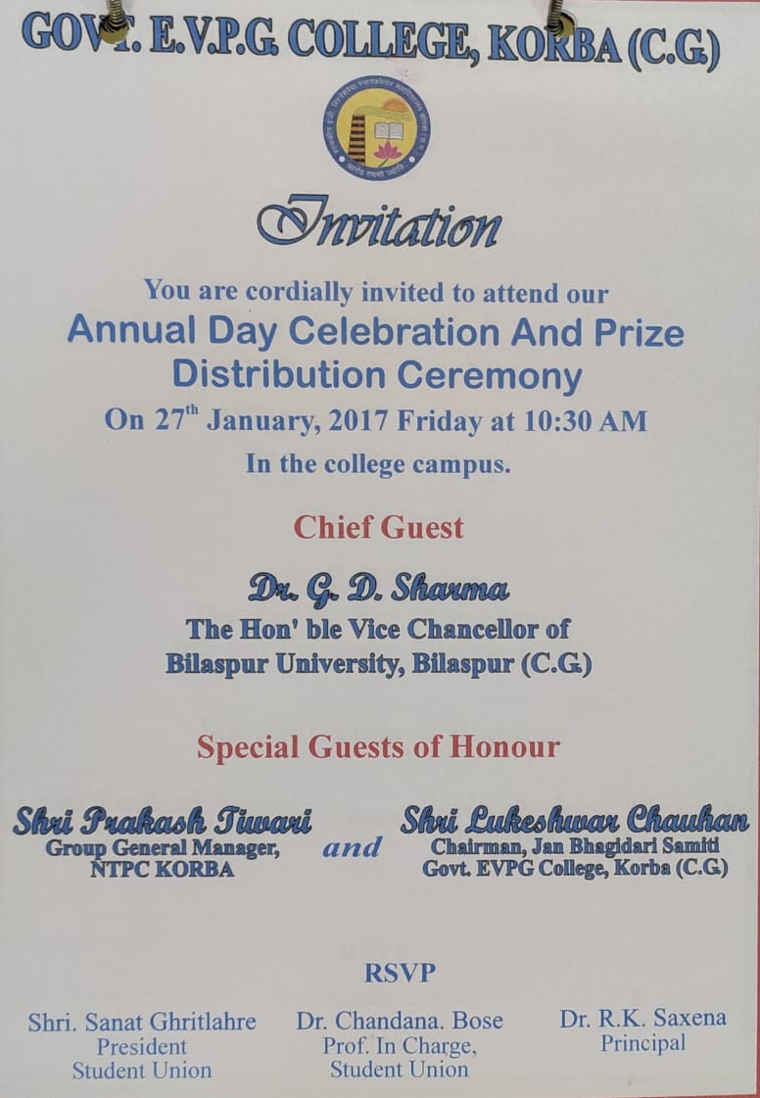

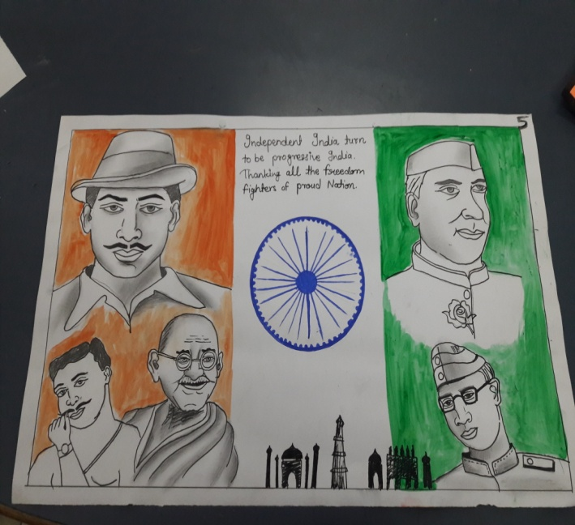
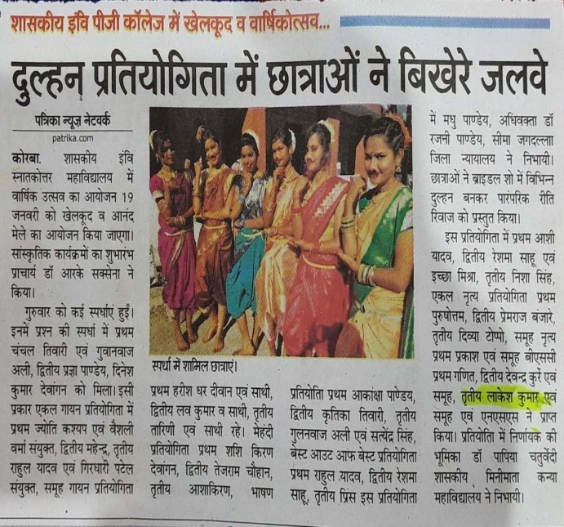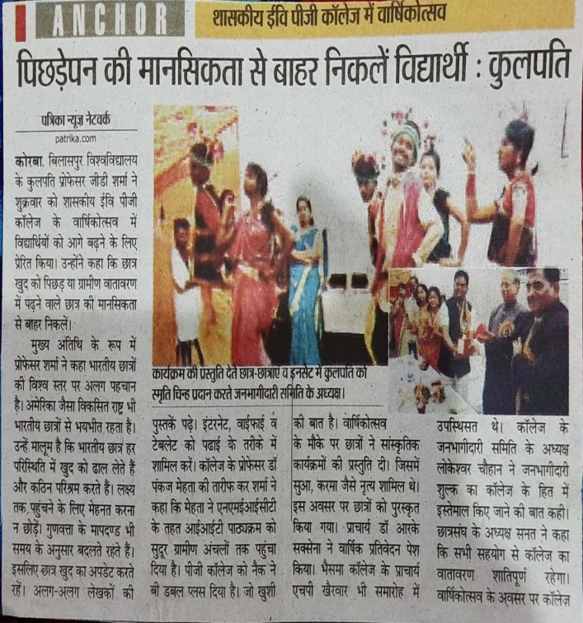

Cultural Meet
Event Coordinator
Date of event
The most awaited cultural event of academic year 2016-17 was organised in the college on................ (Chief Guest) inaugurated the event in the presence of principal............ cultural committee convener in the activities in the inaugural address chief guest highlighted the importance of the extra curriculum activities during the studies. And principal encourage and students to participate in more nos. in all the events irrespective of winning or not. Over ............students of UG Under graduated UG PG dept. competed in ..................... events. eiz., quiz, rangoli, debate, solo song group song, fashion show........... in each categories 3 winners were selected based on their performance the winner awarded with mementos, and certificate on students forum valedictory programme head on .............. In which renowned........................ were the chief guests nearly 300 students witnessed the events as audience.

